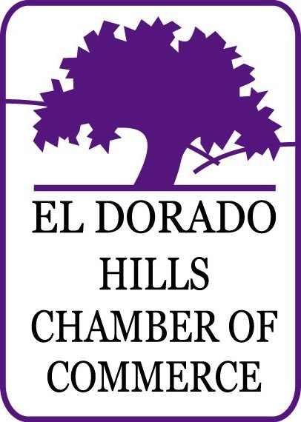
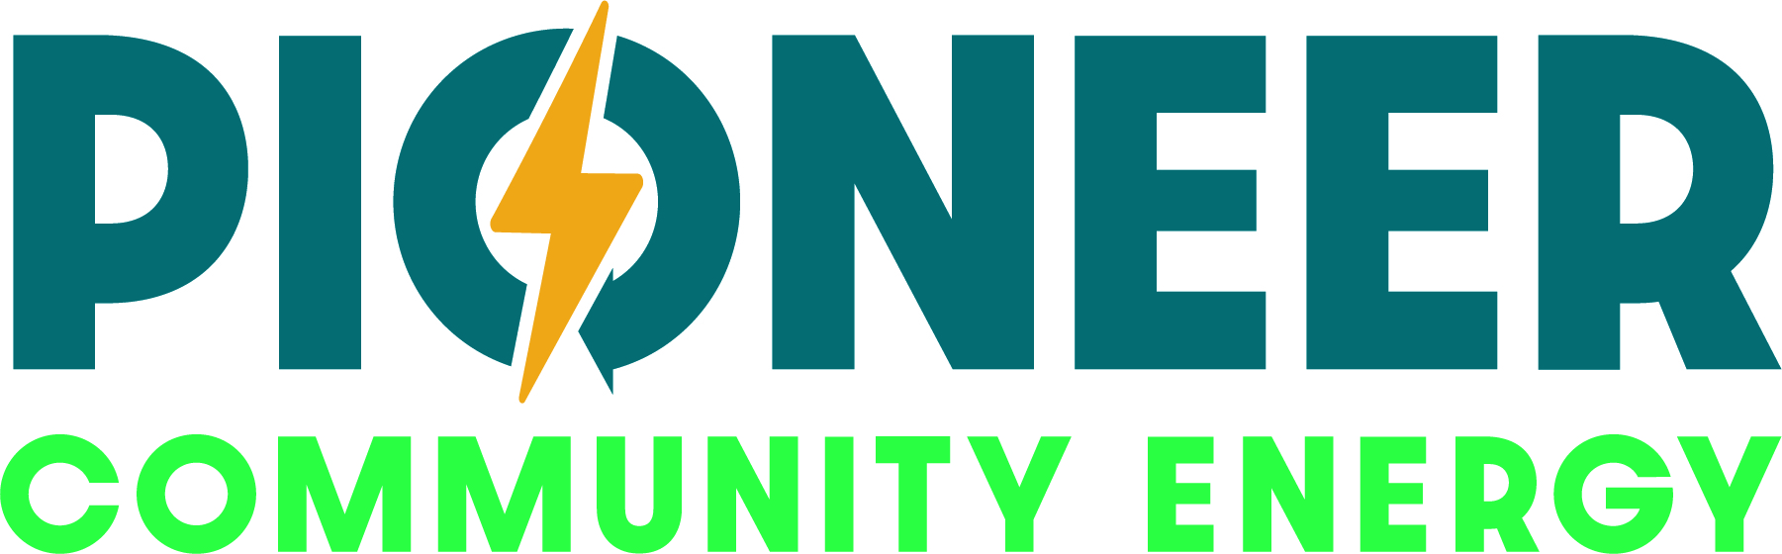
PRESENTS:
El Dorado Hills Business Walk & POST-WALK RECEPTION
Wednesday, October 23, 2024

Pulse on the Local Economy
How’s business (are you profitable?))?
How long have you been in business? Why did you choose EDH?
What is your biggest roadblock?
With these questions, the El Dorado Hills Chamber conducts a survey of the business climate in our area’s business districts. The purpose of Biz Walk is to determine what is going on in the business community and learn first-hand how the Chamber, civic leaders, and County can retain, improve, and attract businesses to our local area.
Teams will visit and interview individual business owners and managers. This provides an opportunity to interact directly with the business and civic leadership of El Dorado Hills, in which we act on their behalf to ensure a prosperous and successful business climate.
NEW
TIME!
Pre-Meeting 1 – 2 PM ● Business Walk Visitations 2 – 3:45 PM ● Post-Walk Reception 4 – 5 PM
Be sure to eat lunch before!

Presenting SPONSOR - $1,000 ($3500 Value) SOLD

- Your name incorporated into the title of the event: XYZ Presents: El Dorado Hills Biz Walk 2024
- Title and logo on the official leave behind bag to every business visited – 150-200 TOTAL
Reach nearly 1,000 Local Businesses just from the postcard!
- Business name incorporated in title & listed in e-News with link.
- Brief business bio in e-News with link.
- Logo in direct mail piece distributed to nearly 1,000 businesses in EDH.
- Marketing item included in promo bag given to visited businesses (max qty 200).
- Event sponsor signage at pre-meeting and post-reception.
- Business name printed on final analysis report with link.

bIZ walk EVENT SPONSOR - $500

Sponsorship: $500 (Value of $1,000)
Reach nearly 1,000 Local Businesses just from the postcard!
- Business name listed in e-News with link.
- Brief business bio in e-News with link.
- Logo in direct mail piece distributed to nearly 1,000 businesses in EDH.
- Marketing item included in promo bag given to visited businesses (max qty 200).
- Event sponsor signage at pre-meeting and post-reception.
- Business name printed on final analysis report with link.

FLYER $150 / PROMO ITEM Sponsor $0 FREE - (200 qty)

- Provide a flyer (paper item) for the promotional bag given to all visited businesses.
- Provide a promotional item (samples/goods) for the bag given to all visited businesses.

El Dorado Hills Chamber

Biz Walk

Sponsorship & WALKER REGISTRATION

DEADLINE – sEPTEMBER 25, 2024

Please check the appropriate box*:

Presenting Sponsor $1,000 SOLD!
Bag items (200 qty) Due: Friday, October 11, 2024
Only 1 available!

Event Sponsor $500
Bag items (200 qty) Due: Friday, October 11, 2024

Flyer Sponsor – brochure/flyer/postcard $150
Flyers (200 qty) Due: Friday, October 11, 2024

Promo Item Sponsor – premiums etc. $0 – FREE
Bag items (200 qty) Due: Friday, October 11, 2024

Team Walker – Have you walked with us before? YES / NO (circle one)
No cost to walk, just your time, and thank you!
WALKER SIGN UPS DUE ASAP

*Member rates.

Business Name: ______________________________________________________

Contact: ______________________________________________________
Phone: ( ) _________________________________________________________

Email: ______________________________________________________________

Check or Credit Card # _________________________________________________

Exp. Date: _____________________ 3 Digit Security Code: ___________

Total Amount Enclosed: $_______ Signature: _______________________________

Sponsorships deadline September 25, 2024

Payment must accompany registration to: El Dorado Hills Chamber of Commerce, 2085 Vine Street,

Ste. 105, El Dorado Hills, CA 95762 or mary@eldoradohillschamber.org (916) 933-1335, ext. 104

