](https://www.patracorp.com/)

**Patra’s Facility/Conference Center:**

**4207 Town Center Blvd, Bldgs. A, El Dorado Hills**

**All Proceed are donated to Patra Public Charity/aka Patra Proud**

**Large Conference Room – 51’ x 43’**

* Banquet setup with five ft round tables and banquet chairs / 6 chairs per table for most comfort / Black tablecloths / seating up to 100.
* Designed for meeting setup with six ft rectangular tables for two with chairs on wheels / Black tablecloths / Seating up to 50-70.
* Rows of Chairs / 100+ Banquet Chairs
* Includes 3-98” mounted TVs for Audio/Video presentations (Zoom). Patra IT will collaborate with clients for setup and support included.

**Large Conference Room Cost:** (we discourage eating in the conference room) – Room setup to meet client’s design. All furniture/Setup/Beak down included.

* Half day - 4 hour minimum $300
* Full day - 8 hours $400

**Large Kitchen** – 65” TV (prep and cooking available)/ **Breakroom/Eating Area** – 86” **TV/Open Area** for meeting & Dining.

* Cost -Half Day $200/Full day $300
* Includes: Microwave, 5 NuWave Electric Burners, Electric Skillets, Air Fryer/Toaster/Over, Dishwasher, Fridge, Silverware, glasses, pans/cookware, serving bowls, utensils…. More options available via discussion.
* Breakroom size varies by attendee size, i.e., can extend into the open area.

**Proof of Liability Insurance / Certificate of Insurance required.**

**Contact: Carl Tarrant – Facilities Director/Event Space Coordinator/Director of Charitable Giving**

**Phone: 916-709-1933**

**Email:** [**ctarrant@patracorp.com**](mailto:ctarrant@patracorp.com)

**Large Conference Room: Setup for 20 & 40 tables (can hold up to 70-78 with tables / 100 without tables**

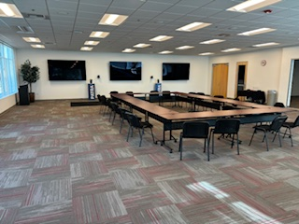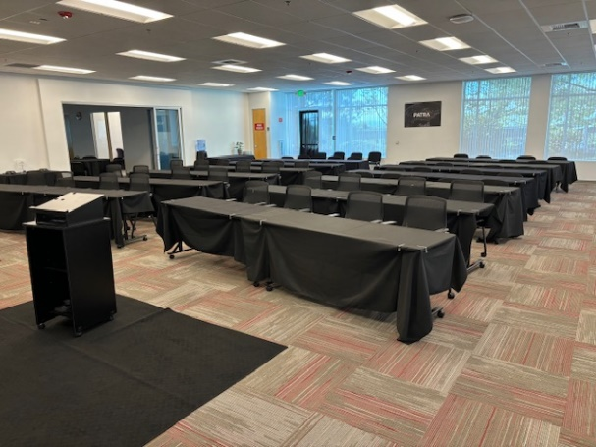

**Open Area for meetings & eating – up to 65+ seating.**

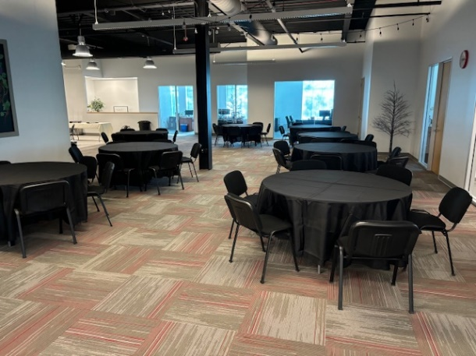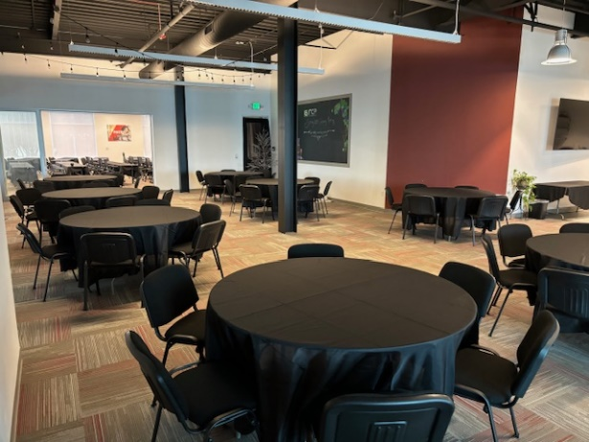

**Kitchen with/without Seating with banquet setup for serving.**

